# Birla Institute of Technology & Science, Pilani Work-Integrated Learning Programmes Division First Semester 2019-2020

**M.Tech (Data Science and Engineering) Mid-Semester Test (EC-2 Regular)**

Course No. : DSECF ZG519

Course Title : DATA STRUCTURE ALGORITHMS AND DESIGN

Nature of Exam : Closed Book

Weightage : 30%

= 2

No. of Pages

Duration : 90 Min

No. of Questions = 7

Date of Exam : 30-06-2019[AN] Note:

1. Please follow all the *Instructions to Candidates* given on the cover page of the answer book.
2. All parts of a question should be answered consecutively. Each answer should start from a fresh page.
3. Assumptions made if any, should be stated clearly at the beginning of your answer.

Answer All the Questions (Only in the pages mentioned against questions. If you need more pages. Continue remaining answers from page 17 onwards)

Question 1: [0.5 X 4 = 2M] [to be answered only in page 1]

* 1. Suggest what type of data structure can be used for the below requirement.
     1. To implement undo button in word processor software.
     2. To implement back button on the browser.
     3. To implement backtracking/maze games
     4. To synchronize packets in a networking environment if the sender is a fast sender and the receiver is a slow receiver.

Question 2: [4M] [ to be answered only in page 2-3]

* 1. Construct a Binary Tree, whose in-order traversal is {4,2,1,7,5,8,3,6} and post-order traversal is {4,2,7,8,5,6,3,1} and also find a pre-order traversal.

Question 3: [4M] [ to be answered only in pages 4-5]

* 1. A Queue is set up in a circular array A[0....n-1] with front and rear defined as usual. Assume that n-1 locations in the array are available for storing the elements (with the other elements being used to detect full/empty condition). Give a formula for the number of elements in the queue in terms of rear, front, and n.

Question 4: [4M] [ to be answered only in pages 6-7]

* 1. Find the complexity of the below recurrence: T(n) =  Question 5: [3M X 2 = 6M] [ to be answered only in pages 8-11]
  2. Suppose we wish to create a binary heap containing the keys: D A T A S T R U C T U R E. (All comparisons use alphabetical order).
     1. Show the resulting min-heap if we build it using successive insert operations (starting from D).
     2. Show the resulting min-heap, if we build it using bottom up heap.

# DSECF ZG519 (EC-2 Regular) First Semester 2019-2020 Page 2

Question 6: [4M] [ to be answered only in pages 12-13]

* 1. Question based on Fig:1, In which order are the vertices visited using Depth first search (DFS) starting from vertex A? (i.e., what is the order of discovery time?) when there is a choice of vertices to visit, use alphabetical order. In what order are the vertices completed using BFS starting from vertex A. (Hint: this question has two parts).

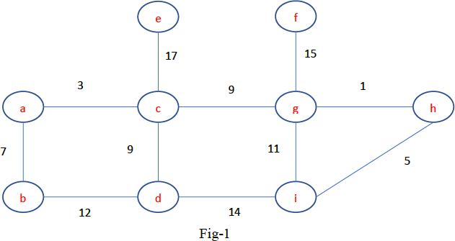

Question 7: [2M x 3 = 6M] [ to be answered only in pages 14-16]

* 1. Consider a hash table of size-7 with hash function h(k) =k mod7. Draw the table that results after inserting, in the given order the following values: 19,26,13,48,17 for the three scenarios below.
     1. When collisions are handled by separate chaining.
     2. When collisions are handled by linear probing
     3. When collisions are handling by double hashing using a second hash function h’(k) =5-(k mod 5).

*** ALL THE BEST ***